Exercise 1:

import java.util.Scanner;

class Bmi{

static double weight, height, bmi;

public static double bmi_cal(double weight, double height)

{

bmi=(weight/(height*height))*703;

return bmi;

}

public static String findStatus(double bmi)

{

String status;

if (bmi<18.5)

{

status="Underweight";

return status;

}

else if (bmi>=18.5&& bmi<=24.9)

{

status="Normal";

return status;

}

else if (bmi>=25.0 && bmi<=29)

{

status="Overweight";

return status;

}

else if (bmi>=30.0)

{

status="Obese";

return status;

}

else

return " ";

}

public static void main(String args[])

{

Scanner inp= new Scanner(System.in);

System.out.println("Enter your weight in pounds");

double w=inp.nextDouble();

System.out.println("Enter your height in inches");

double h=inp.nextDouble();

System.out.println(bmi_cal(w,h));

System.out.println(findStatus(bmi));

}

}

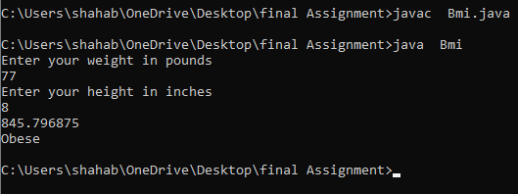

Exercise 2:

class hey{

int a;

char b;

static int method(int a, char b)

{

return a;

}

static int method(char b, int a)

{

return b;

}

public static void main(String args[])

{

System.out.println(method(1,'a'));

System.out.println(method('a',1));

}

}

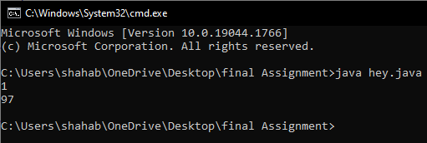

Exercise 3:

class num{

int a;

int lastdigit(int a)

{

return a%10;

}

public static void main(String args[])

{

num obj=new num();

System.out.println(obj.lastdigit(3852));

}

}

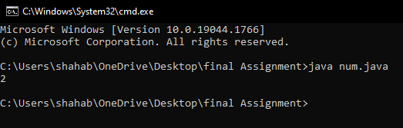

Exercise 4:

import java.util.Scanner;

public class GCD {

public static void main(String[] args) {

int n1, n2;

Scanner inp=new Scanner(System.in);

System.out.println("Enter the number 1");

n1=inp.nextInt();

System.out.println("Enter the number 2");

n2=inp.nextInt();

int hcf = hcf(n1, n2);

System.out.printf("G.C.D of %d and %d is %d.", n1, n2, hcf);

}

public static int hcf(int n1, int n2)

{

if (n2 != 0)

return hcf(n2, n1 % n2);

else

return n1;

}

}

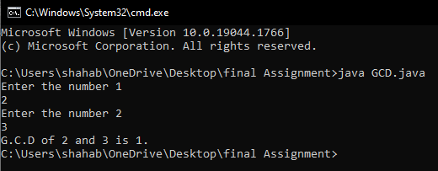

Exercise 5:

class ReverseStringExample2

{

void reverseString(String string)

{

if ((string==null)||(string.length() <= 1))

System.out.println(string);

else

{

System.out.print(string.charAt(string.length()-1));

reverseString(string.substring(0,string.length()-1));

}

}

public static void main(String[] args)

{

String str = "OOPS is fun";

ReverseStringExample2 rs = new ReverseStringExample2();

rs.reverseString(str);

}

}

